**AMBER**

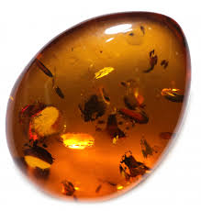 **Name:** Burmese Amber

**Brand:**  Kosta Boda

**Model#:** 004

**Color:** Multi-Shade

**Price: $1000 million**